SIF Object Proposal and Plan: Identified Issues
Assessment Workgroup – Additions and New Objects

Submitted by: Assessment Workgroup
Version: 2.1
Date Submitted: 1/5/2007

Table of Contents

Objects and Change Proposal 2
Business Case/Issues 2
Time Line 2
Objects Plan 4
Issue 1 4
Issue 2 5
Issue 3 6
Issue 4 6
Infrastructure Changes 6
Test Cases 7
Test Case 1 7
Test Case 2 8
Test Case 3 9
Test Case 4 9
Test Case 5 9

Draft Specification Document Version Control
Version | Date: | Author/Organization: | Comments
v0.1 | 1/5/2007 | AWG
v0.1 | 2/1/2007 | Vince
v1.0 | 2/5/2007 | Vince
v1.1 | 3/7/2007 | Vince | Added AssessmentAdministration RefId to StudentScoreSet and StudentResultSet as a result of testing of objects.
v1.21 | 4/24/2007 | Vince | Removed Assessment/AssessmentDescriptors because of lack of review.

Objects and Change Proposal

Business Case/Issues

- Agents subscribing to Assessment have no way of knowing what type of assessment is represented in an instance. There is no characteristic information in the current Assessment object to allow an agent to categorize the assessment in any way—no NCES codes, no local identifier, nothing to represent the state-defined code for the assessment (if any), no way to know if it is a state assessment, a district assessment (like required for graduation), a course-specific assessment, an SAT or ACT test.

Other types of assessments: assessment for assignment, assessment for a lesson.

- Assessment scores can only be reported by subtest, but subtests are not required in AssessmentForm. So if you don’t identify subtests in AssessmentForm and track them, too, you can’t get scores for assessments. You can’t associate one score with an AssessmentForm or AssessmentRegistration, either, without identifying a subtest.

- Assessment Subtest currently allows the reporting of events. Assessment Subtest allows recursive references to itself. It has been pointed out that a change event on an Assessment Subtest could trigger unknown cascading changes.

Time Line
The 2.1 timeline as posted on the Tech Board community site.

Object Relationship Diagram
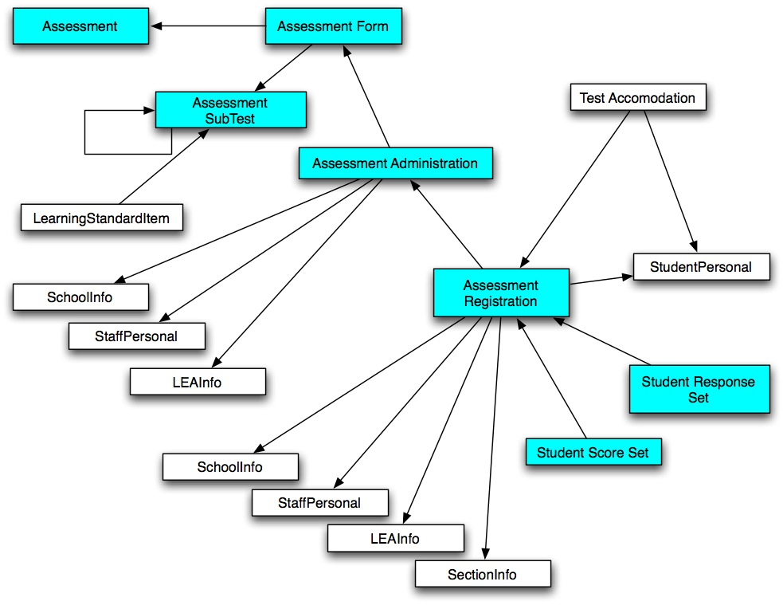

Objects Plan

Issue 1

Issue Summary

The Assessment object needs more elements to transmit assessment characteristics.

Current Assessment object

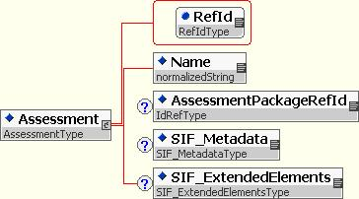

Proposed Changes
- Add AssessmentDescriptorsList element.

- Add Assessment Id element. This is the state, local or publisher unique id for the assessment.

Proposed Changed Object

Note: The AssessmentDescriptors element has been removed.

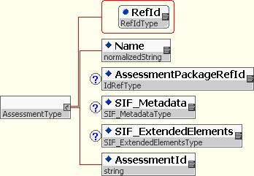

Example XML

<Assessment xmlns = "http://www.sifinfo.org/infrastructure/2.x" xmlns:xsi = "http://www.w3.org/2001/XMLSchema-instance" xsi:schemaLocation = "http://www.sifinfo.org/infrastructure/2.x ../assessment_proposed.xsd">only text
<!---->
<Name>TAKS Test</Name>
<AssessmentPackageRefId>aaabb</AssessmentPackageRefId>
<SIF_Metadata>
</SIF_Metadata>
<SIF_ExtendedElements>
</SIF_ExtendedElements>
<AssessmentDescriptors>
<!--(Descriptor+)-->
<Descriptor Type = "NCESCode">0100</Descriptor>
<Descriptor Type = "AssessmentLevel">State</Descriptor>
<Descriptor Type = "AccountabilityType">Required for Graduation</Descriptor>
</AssessmentDescriptors>
<AssessmentId>TX48A</AssessmentId>
</Assessment>

Issue 2

Issue Summary

The Assessment Form object should have at least one subtest in order to be valid.

Proposed Change

- Change the subtest reference in Assessment Form from optional to mandatory.

- Change Assessment Form from reports events to does not report events.

Response to Issue 2

The requirement to track assessment forms in order to get scores is by design. Assessment Form contains information crucial to interpretation of scores. In many application data models, assessment and assessment form are collapsed into a single record. Sometimes even assessment, assessment form and assessment administration are collapsed into a single record. Notice that at this time, events are not reported for the Assessment object.

A zone may need to have an Assessment and AssessmentForm pair exist before the subtests have been developed or published. The change from optional to mandatory for the subtest reference in AssessmentForm is not recommended.

Issue 3

Issue Summary

Assessment Subtest currently allows the reporting of events. Assessment Subtest allows recursive references to itself. It has been pointed out that a change event on an Assessment Subtest could trigger unknown cascading changes.

Also, in many instances Assessment, Assessment Form, and Assessment Subtest information is stored as a single record in databases. By not allowing events for these three object, it will be easier for agents to keep these types of records up to date. An agent will request this information once, then listen for events or request information for the other objects.

Proposed Change

For the above reason, we propose that events not be reported for Assessment Subtest.

Issue 4

Issue Summary

In testing of the assessment objects it has been discovered that requesting of result sets and score sets is awkward. This is because there is a one-to-one relationship between AssessmentRegistration and StudentScoreSet and a one-to-one relationship between AssessmentRegistration and StudentResultSet. As currently designed, a requester must request AssessmentRegistration by AssessmentAdministration RefId and then must request each StudentScoreSet or StudentResultSet one at a time.

Proposed Change

It is proposed that AssessmentAdministration RefId be added to StudentScoreSet and StudentResultSet. This makes the use of AssessmentRegistration optional unless the information in that object is needed. If information from both objects is needed then a request can be made for both objects using just one query for each.

Infrastructure Changes
No changes to infrastructure are anticipated.

